A Machine Learning Approach for Crop Yield Prediction Using Agricultural and Environmental Factors

Abstract— Accurate crop yield prediction is challenging due to the influence of agricultural and environmental factors such as rainfall, temperature, fertilizer usage, crop type, and regional conditions. Existing approaches employ various machine learning, hybrid, and deep learning techniques, but many involve complex models or multiple data sources, making them less suitable for simple and practical implementation. This paper presents a machine learning approach for crop yield prediction using relevant agricultural and environmental attributes. The proposed workflow includes data preprocessing, exploratory data analysis, feature engineering, feature selection, and comparison of Linear Regression, Decision Tree Regressor, and Random Forest Regressor models. The models will be evaluated using MAE, RMSE, and R² to identify the best-performing model. An interactive dashboard will further present the predicted yield and relevant agricultural insights. The proposed approach aims to provide a practical and interpretable solution for data-driven crop yield prediction.
Keywords— Crop Yield Prediction, Machine Learning, Agricultural Data, Environmental Factors, Regression, Data Analytics

Introduction
The agricultural sector plays an important role in food production and economic development, while crop yield is influenced by several factors such as rainfall, temperature, fertilizer usage, crop type, and regional conditions. Variations in these factors make accurate crop yield estimation a challenging task. Traditional yield estimation methods often rely on historical records and conventional analysis, which may not adequately capture the relationships between multiple influencing factors.
Machine learning techniques have increasingly been applied to crop yield prediction by learning patterns from historical agricultural and environmental data. Existing studies have explored regression, ensemble, hybrid, and deep learning approaches for improving prediction accuracy. However, many existing approaches involve complex models, extensive feature combinations, or multiple external data sources, which can increase implementation complexity and reduce practical usability.
To address these limitations, this paper presents a machine learning approach for crop yield prediction using relevant agricultural and environmental factors. The proposed workflow consists of data preprocessing, exploratory data analysis, feature engineering, feature selection, and machine learning model development. Linear Regression, Decision Tree Regressor, and Random Forest Regressor will be trained and compared using MAE, RMSE, and R² metrics.
The main contribution of the proposed approach is a practical and comparatively simple crop yield prediction workflow that combines relevant feature analysis, model comparison, and interactive visualization. The selected model will be integrated into a dashboard to present crop yield predictions and supporting agricultural insights in an accessible manner.

LITERATURE REVIEW
Recent studies have explored machine learning techniques for crop yield prediction using agricultural, environmental, climatic, and crop-specific data. These studies demonstrate the potential of machine learning for improving yield prediction while also highlighting limitations related to model complexity, feature selection, data requirements, and regional applicability.
Abdel-salam et al. [1] proposed a framework for crop yield prediction using a hybrid feature selection approach and optimized machine learning. The study emphasizes the importance of selecting relevant features and optimizing the prediction model. However, the use of hybrid feature selection and optimization increases the complexity of the overall prediction framework. [1]
Sri Nagesh et al. [2] proposed a boosting-enabled machine learning technique for accurate crop yield prediction towards precision agriculture. The study demonstrates the effectiveness of boosting-based techniques for agricultural prediction. However, the approach focuses primarily on boosting techniques, leaving scope for comparison with simpler and more interpretable regression models. [2]
Ashfaq et al. [3] presented a wheat yield prediction approach using machine learning and climate-NDVI data fusion. The study combines climatic and satellite-derived NDVI information to improve prediction performance. However, the integration of multiple data sources increases data requirements and implementation complexity, and the approach is focused specifically on wheat yield prediction. [3]
El-Kenawy et al. [4] investigated potato crop yield prediction using both machine learning and deep learning techniques for sustainable agriculture. The study demonstrates the applicability of advanced computational models for crop yield prediction. However, the use of multiple machine learning and deep learning architecture can increase computational requirements and model complexity. [4]
Thimmegowda et al. [5] conducted a comparative analysis of machine learning and statistical models for cotton yield prediction in major growing districts of Karnataka, India. The study highlights the importance of comparing different prediction techniques for regional crop yield estimation. However, its focus on a specific crop and selected districts limits the general applicability of the approach to other crops and regions. [5]

Research Gap
From the reviewed studies, it can be observed that existing crop yield prediction approaches frequently employ optimized, boosting, hybrid, or deep learning techniques, which can increase implementation complexity. Some approaches also depend on multiple data sources or focus on specific crops and regions. Comparatively, there is scope for a simple and practical machine learning workflow that uses relevant agricultural and environmental factors, compares standard regression models, and provides an accessible prediction interface. The proposed work addresses this gap by combining feature analysis, conventional machine learning model comparison, performance evaluation, and interactive visualization within a single crop yield prediction workflow.

PROPOSED METHODOLOGY
The proposed system aims to predict crop yield using relevant agricultural and environmental factors through a structured data science and machine learning workflow. The methodology consists of data collection, preprocessing, exploratory data analysis, feature engineering and selection, machine learning model development, model evaluation, and interactive dashboard development. The overall workflow is designed to provide a simple, practical, and interpretable approach to crop yield prediction.
A. Data Collection
The dataset used for the proposed system contains historical agricultural and environmental information relevant to crop yield prediction. The major attributes include crop type, region or state, rainfall, temperature, fertilizer usage, and crop yield. The collected data provides the basis for identifying relationships between agricultural conditions and crop productivity. A single integrated dataset is used to simplify the implementation and maintain consistency throughout the prediction workflow.
B. Data Preprocessing
The collected dataset is first inspected to identify missing values, duplicate records, inconsistent data, and irrelevant attributes. Missing values are handled using appropriate preprocessing techniques, while duplicate records are removed to improve data quality. Categorical attributes such as crop type, season, and region are converted into numerical representations using encoding techniques. Features that are not useful for prediction or may introduce data leakage are excluded from the model training process.
C. Exploratory Data Analysis
Exploratory Data Analysis (EDA) is performed to understand the characteristics and relationships within the dataset. Statistical summaries and visualization techniques are used to examine feature distributions, identify patterns, and detect potential outliers. Relationships between agricultural and environmental factors and crop yield are analyzed using correlation analysis and graphical visualizations. The results of EDA help identify potentially influential features for the prediction models.
D. Feature Engineering and Selection
Feature engineering is performed to derive useful information from the available agricultural and environmental attributes. Where appropriate, numerical transformations or derived features are created to improve the representation of the data. Feature selection is then applied to identify the most relevant predictors for crop yield. Removing less informative features helps reduce unnecessary model complexity and can improve prediction efficiency.
E. Machine Learning Model Development
The processed dataset is used to develop regression models for crop yield prediction. Three machine learning algorithms are considered: Linear Regression, Decision Tree Regressor, and Random Forest Regressor. Linear Regression provides a simple baseline model, while Decision Tree Regressor captures nonlinear relationships between input features and yield. Random Forest Regressor combines multiple decision trees to improve predictive performance and robustness. The models are trained using the selected features and compared under the same experimental conditions.
F. Model Evaluation and Selection
The developed models are evaluated using Mean Absolute Error (MAE), Root Mean Square Error (RMSE), and R² Score. MAE measures the average magnitude of prediction errors, RMSE gives greater importance to larger errors, and R² indicates how well the model explains the variation in crop yield. The performance of all three models is compared, and the model providing the most suitable combination of prediction accuracy and practical interpretability is selected as the final prediction model.
G. Interactive Dashboard Development
An interactive dashboard is proposed to provide an accessible interface for crop yield prediction and analysis. The selected machine learning model can be integrated into a Streamlit application, allowing users to provide relevant agricultural and environmental inputs and obtain the predicted crop yield. The dashboard can also present important dataset insights, model performance, and visualizations to support easier interpretation of the prediction results.

PROPOSED IMPLEMENTATION
The proposed Crop Yield Prediction system will be implemented as a structured Data Science and Machine Learning workflow for predicting agricultural crop yield using relevant agricultural and environmental factors. The implementation will follow the stages of data preprocessing, exploratory data analysis, feature engineering and selection, regression model development, model evaluation and comparison, and interactive dashboard development.
The overall workflow of the proposed Crop Yield Prediction approach is shown in Fig. 1.
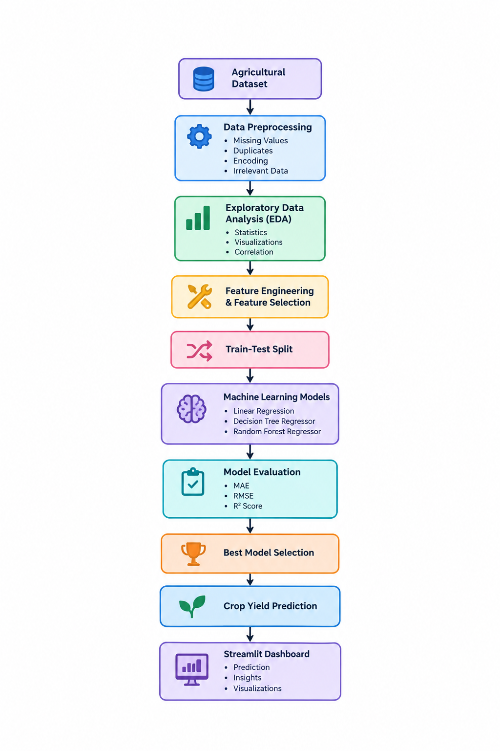
Fig. 1. Proposed Crop Yield Prediction workflow.
The cleaned dataset obtained after preprocessing will be used for further analysis. Exploratory analysis will be performed to examine crop yield patterns and relationships between agricultural and environmental factors using statistical summaries and visualizations. Feature engineering and selection will then be performed to identify the most relevant attributes for crop yield prediction.
The selected features will be used to train Linear Regression, Decision Tree Regressor, and Random Forest Regressor models. The resulting predictions will be evaluated using MAE, RMSE, and R² Score to compare the performance of the developed models. The best-performing model will be selected for the final crop yield prediction task.
Finally, the prediction results and analytical findings will be presented through an interactive Streamlit dashboard containing views related to crop yield patterns, important agricultural factors, model performance, and predicted yield.
The proposed implementation is intended to provide an integrated workflow that connects data preparation, exploratory analysis, feature selection, machine learning, model evaluation, prediction, and visualization within the Crop Yield Prediction project.

EXPECTED RESULTS AND OUTCOMES
The proposed Crop Yield Prediction system is expected to provide a structured and practical approach for estimating agricultural crop yield using relevant agricultural and environmental factors. The implementation is expected to produce meaningful insights into the relationship between crop yield and factors such as rainfall, temperature, fertilizer usage, crop type, and regional conditions.
The preprocessing and exploratory analysis stages are expected to produce a clean and well-structured dataset along with visual insights into crop yield patterns and feature relationships. Feature engineering and selection are expected to identify the most relevant attributes that contribute to crop yield prediction while reducing unnecessary model complexity.
The implementation of Linear Regression, Decision Tree Regressor, and Random Forest Regressor is expected to provide a comparative understanding of different regression approaches for yield prediction. Model evaluation using MAE, RMSE, and R² Score will help identify the best-performing model based on prediction accuracy.
The final system is expected to provide crop yield predictions through an interactive Streamlit dashboard. The dashboard will allow users to view prediction results, agricultural insights, and model performance in an accessible format.
Overall, the proposed system is expected to demonstrate how data analytics and machine learning can be combined to support data-driven crop yield estimation and provide a foundation for future agricultural decision-support applications.

CONCLUSION
This paper presents a practical machine learning approach for crop yield prediction using relevant agricultural and environmental factors. The proposed workflow integrates data preprocessing, exploratory data analysis, feature engineering, feature selection, regression model development, and performance evaluation into a structured prediction system.
Linear Regression, Decision Tree Regressor, and Random Forest Regressor are considered to compare different regression approaches for crop yield estimation. The models will be evaluated using MAE, RMSE, and R² Score to identify the most suitable model for the given dataset. The integration of the selected model with an interactive Streamlit dashboard is expected to make the prediction results easier to access and interpret.
The proposed approach provides a simple and scalable foundation for applying data science and machine learning techniques to agricultural yield prediction. By analyzing relationships between environmental and agricultural factors, the system can support data-driven understanding of crop productivity and provide a basis for future agricultural decision-support applications.

FUTURE SCOPE
The proposed Crop Yield Prediction system can be further enhanced by incorporating real-time and additional agricultural data to improve prediction accuracy and practical applicability. Future versions can integrate real-time weather conditions, detailed soil nutrient information, irrigation data, and other environmental factors to provide more comprehensive yield predictions.
Satellite imagery and remote sensing data can also be incorporated to capture crop health, vegetation conditions, and spatial variations across agricultural regions. Pest and disease information could further improve the system by considering factors that can negatively affect crop productivity.
The machine learning component can be extended by incorporating advanced algorithms and deep learning techniques and comparing their performance with the conventional models used in the proposed system. With sufficient real-time and historical data, the system could also be extended to provide agricultural recommendations related to crop selection, irrigation, and resource management.
In the future, the dashboard can be enhanced with real-time data integration, regional-level visualizations, and personalized recommendations, transforming the proposed prediction system into a more comprehensive agricultural decision-support platform.
REFERENCES
[1] M. Abdel-salam, N. Kumar, and S. Mahajan, “A Proposed Framework for Crop Yield Prediction Using Hybrid Feature Selection Approach and Optimized Machine Learning,” 2024.
[2] O. Sri Nagesh et al., “Boosting Enabled Efficient Machine Learning Technique for Accurate Prediction of Crop Yield Towards Precision Agriculture,” 2024.
[3] M. Ashfaq, I. Khan, A. Alzahrani, M. U. Tariq, H. Khan, and A. Ghani, “Accurate Wheat Yield Prediction Using Machine Learning and Climate-NDVI Data Fusion,” 2024.
[4] E.-S. M. El-Kenawy, A. A. Alhussan, N. Khodadadi, S. Mirjalili et al., “Predicting Potato Crop Yield with Machine Learning and Deep Learning for Sustainable Agriculture,” 2024/2025.
[5] M. N. Thimmegowda, M. H. Manjunatha, H. Lingaraj et al., “Comparative Analysis of Machine Learning and Statistical Models for Cotton Yield Prediction in Major Growing Districts of Karnataka, India,” 2025.

